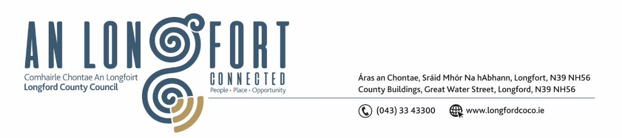

**LONGFORD MUNICIPAL DISTRICT**

**Minutes of Meeting of Longford Municipal District held in the Council Chamber Aras an Chontae and via MS Teams on Wednesday, 26 October 2022 at 3.30pm**

**CATHAOIRLEACH**: Councillor Gerry Hagan

**MEMBERS PRESENT**: Councillors – Seamus Butler, Martin Monaghan, Uruemu Adejinmi, John Browne, Peggy Nolan, and Gerry Warnock

**IN ATTENDANCE**: Mr. John Brannigan, Director of Services

Mr. Eamonn Bennett, Senior Executive Engineer

Ms. Lorraine Mc Kee, Administrative Officer

Ms. Fema Flanagan, A/Head Of Finance

**MEETINGS**

**ADMINISTRATOR:**  Ms. Ann Marie Mc Keon

**ADOPTION OF MINUTES – circulated**

On the proposal of Councillor seconded by Councillor it was unanimously agreed to adopt Committee Minutes of Meeting of Longford Municipal District Committee Meeting held on the 28 September 2022.

On the proposal of Councillor Seamus Butler seconded by Councillor Uruemu Adejinmi, it was unanimously agreed to adopt Minutes of the Longford Municipal District Meeting held on the 28 September 2022.

**MATTERS ARISING FROM MINUTES**

None.

**DECLARATION OF INTEREST BY MEMBERS**

None.

**MANAGEMENT REPORT**

The Management Report, as circulated, was noted. Councillor Seamus Butler noted that no consultation took place with businesses in the Grafton Court area regarding the restoration works that are on-going and he requested that in future before any works commence that the Council would consult with the businesses in the area of the work. Councillor Butler requested that the pothole at Blind Man’s Walk be repaired, and Seamus asked for an update on the soccer park for the next meeting.

**CONSIDERATION OF THE 2023 GENERAL MUNICIPAL ALLOCATION**

Fema Flanagan, A/Head of Finance gave a comprehensive presentation regarding the General Municipal Allocation 2023 under the following headings and replied to queries raised –

* Budgetary Process – under Local Government Reform Act 2014
* Local Property Tax Variation – retain rates for 2023 and 2024
* Source of Funding for Municipal District
* Acute Financial Challenges for 2023
* Delivery of Services with decreasing resources
* Lowest valued LPT base in Country
* Ukrainian Humanitarian Crisis
* Increased Inflationary Pressure
* Financing Payroll requirements and additional pay increases
* Ability to provide ‘match-funding’ for a range of schemes
* Decrease in NPPR income stream
* Loss of rates from Lough Ree Power Station
* Low Rates Base/High Vacancy Rate
* General Municipal Allocation 2023 Recommendation - €90,000 to be distributed as follows – Tidy Town Grants – Town Twinning –– Voluntary Bodies Grants.
* Longford MD 2022 GMA Committed to date – 36 Groups received funding in 2022
* Governance

**Longford GMA Sub-Service Allocation 2023**



Fema provided detailed responses to all the questions raised.

On the proposal of Councillor Seamus Butler, seconded by Councillor Uruemu Adejinmi, the members unanimously approved the 2023 General Municipal Allocation as presented.

**CONSIDERATION OF FREE PARKING ARRANGEMENTS DURING THE CHRISTMAS PERIOD**

On the proposal of Councillor Peggy Nolan, seconded by Councillor Seamus Butler the members approved the Free Parking arrangements as circulated. Councillor Butler requested that that the appropriate signage be erected on the approach roads to the town as in previous years.

**LONGFORD TOWN CHRISTMAS LIGHTS**

On the proposal of Councillor Seamus Butler, seconded by Councillor Peggy Nolan the members unanimously agreed to have the turning on of the Christmas Lights in Longford Town on the 26 November 2022.

Director of Services, John Brannigan informed the members that there will be a reduction in the number of lights this year as we are obliged to reduce energy consumption and costs.

**CONSIDERATION OF APPLICATION FROM LONGFORD TOWN TWINNING.**

On the proposal of Councillor Uruemu Adejinmi, seconded by Councillor Peggy Nolan the members unanimously approved the Longford Town Twinning application as circulated.

**NOTICES OF MOTIONS, SUBMITTED BY COUNCILLORS:**

**Shrubbery at St. Mel’s Car Park**

The following Notice of Motion was proposed by Councillor John Browne and seconded by Councillor Peggy Nolan-

I call on Longford County Council to have the bushes and shrubbery cut and tidied in the car park adjacent to St. Mel’s Cathedral on St. Mel’s Road.

**Response**

Longford County Council employees trimmed back and pruned the shrubs, bushes and hedges in the Cathedral car park.

**Naming of Carriglass Roundabout**

The following Notice of Motion was proposed by Councillor Gerry Hagan and seconded by Councillor Peggy Nolan -

I call on Longford Municipal District to name the roundabout at Carriglass after Tom Reddington. It is fitting that this will happen this year as it celebrates the 100-year anniversary of Tom Reddington’s death at Carriglass during the Civil War. Tom was Operations Commander for county Longford during the War of Independence.

**Response**

This motion will be referred to the Place-naming Committee for consideration.

**CORRESPONDENCE DATED 19 OCTOBER 2022 RECEIVED FROM IRISH**

**WATER RE REQUEST TO ATTEND A FULL LONGFORD COUNTY COUNCIL**

**MEETING – CIRCULATED**

Noted.

This concluded the business of the meeting.

**Signed: ____________________**

**Ann Marie Mc Keon,**

**Meetings Administrator.**

**Confirmed and adopted at Longford Municipal District Meeting held on the 23 November 2022.**

**Signed: _______________**

**Cathaoirleach.**